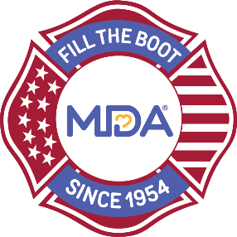

#### Contact: [Local MDA Name] [Local MDA Title] [Local MDA Phone] [Local MDA Email]

#### MDA Partners with [City] Fire Fighters to

#### Kick Off Annual Fill the Boot Campaign

#### 

**[CITY (ALL CAPS)], [State], [Month] [Day], 2024 —** A special kick off event for the annual Fill the Boot drive is being hosted by members of the [Fire Department name], along with the Muscular Dystrophy Association (MDA), to raise critical funds to empower families living with muscular dystrophy, ALS, and related neuromuscular diseases to live longer, more independent lives.

The kick off event on [Date] at [Location] continues this honored fire fighter tradition of dedicating their time to raise critical funds to support research, care, and advocacy for families in our community living with muscular dystrophy, ALS and related neuromuscular diseases.

[Insert specific kick off event activities here. Include spokespeople and speakers, additional partners, MDA families and local notable VIPs that will be in attendance].

On [Today/Date] at [Time], this year’s Fill the Boot drive will officially begin at [FTB location(s)]. More than [number] members of the [Fire Department name] will greet [motorists on the street/customers outside the store] all over the city, asking them to donate to help MDA lead the way in accelerating research, advancing care, and advocating for the support of our families.

Contributions from 2024 [City’s] Fill the Boot will fund groundbreaking research for promising treatments and therapies and provide families with the highest quality care from the best doctors and medical teams in the country at some of the largest nationwide network of multidisciplinary Care Centers including [insert local care center]. The MDA Resource Center, MDA Summer Camp, MDA Community Education and Access programming is also supported by funds raised from Fill the Boot and ensures no one goes through their journey with neuromuscular disease alone.

**About Muscular Dystrophy Association**

Muscular Dystrophy Association (MDA) is the #1 voluntary health organization in the United States for people living with muscular dystrophy, ALS, and related neuromuscular diseases. For over 70 years, MDA has led the way in accelerating research, advancing care, and advocating for the support of our families. MDA’s mission is to empower the people we serve to live longer, more independent lives. To learn more visit [mda.org](https://www.mda.org/) and follow MDA on [Instagram](https://www.instagram.com/mdaorg/), [Facebook](https://www.facebook.com/MDAOrg/), [Twitter](https://twitter.com/MDAorg), [TikTok](https://www.tiktok.com/@mdaorg), and [LinkedIn](https://www.linkedin.com/company/225521/admin/).

**- MDA -**

