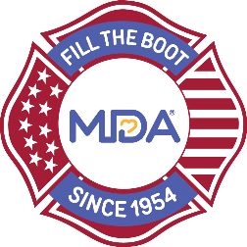

**[City] Fill the Boot Media Kickoff Agenda**

**[Insert Date]**

|  |  |  |
| --- | --- | --- |
| **Time** | **Speaker** | **Agenda Items** |
| **3 - 5 minutes** | [City] Department Fire Chief [Name] | Opening remarks & purpose of today’s event |
| **2 minutes** | Fill the Boot Coordinator [Name] | History of Fill the Boot:  [City & Fire Department] |
| **2 minutes** | Fill the Boot Coordinator [Name] | Announcement of 2024 Dates & Goal |
| **2 minutes** | Mayor [Name] of [City] or City Council member [Name] or both if they would both like to speak | Read the Proclamation & introduce local individual of family served by MDA |
| **2-3 minutes** | [Name of local individual or family served by MDA] | Comments & thank-you message |
| **2-3 minutes** | Fill the Boot Coordinator [Name] | Closing Comments |
| **Close** | [Name of local individual or family served by MDA] passes the boot for first donations. | Pass the Boot |
| **Photo Opportunity should include the Mayor and City Officials, the Fire Chief, the Fill the Boot Coordinator, local individuals/families served by MDA in front of podium or apparatus (E.G., truck) with Fill the Boot banner.** | | |

**Note:** Aim to keep the entire event right around 30 minutes. At the end of the press conference the Fill the Boot Coordinator as well as local MDA representatives and individuals/families served by MDA should be available for media interviews.