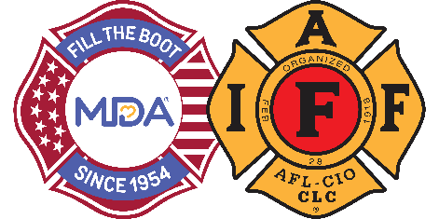
FOR IMMEDIATE RELEASE

Contact:
Contact Name
Contact Email
Contact Phone

[Professional Fire Fighters Association Local ##] [Launches/Join] Annual MDA Fill the Boot Campaign in [City]
2024 marks the 70th anniversary of IAFF and MDA’s long-standing partnership.
CITY (ALL CAPS), State, Month Day, 2024— The International Association of Fire Fighters (IAFF) has collected critical funds in the community since 1954 – one dollar at a time – as part of the Fill the Boot program for the Muscular Dystrophy Association (MDA). The Professional Fire Fighters Association Local ## will continue this tradition as its members kick off the annual program raising funds to support groundbreaking research for promising treatments and therapies and provide families with the highest quality care from the best doctors and medical teams in the country.

Dedicated fire fighters from Professional Fire Fighters Association Local ## will hit the streets/storefronts with boots in hand asking pedestrians, motorists, customers, and other passersby to donate to MDA on Dates at Time, at FTB location(s).

The partnership between MDA and IAFF began in 1954 when the IAFF signed a resolution designating MDA its charity of choice and vowed to continue raising awareness and funds until cures are found. To date, the seven-decade partnership has raised more than $700 million with these funds allowing MDA to invest more than $1 billion in research. These investments have led in-part to many major medical and scientific advances, including the development of more than 20 new FDA approved treatments just since 2015.

In addition to organizing thousands of Fill the Boot events in hometowns across America, fire fighters also dedicate countless hours every year to volunteer at MDA Summer Camp, working with children and young adults living with muscular dystrophy and related neuromuscular diseases. MDA and IAFF also joined to create an educational initiative to raise awareness and provide resources for fire fighters impacted by Amyotrophic Lateral Sclerosis (ALS), also known as Lou Gehrig’s disease.

“For 70 years, the Muscular Dystrophy Association’s Fill the Boot campaign has raised critical funds for research and care for people who live with a neuromuscular disease, and we are honored to be a part of their effort for this important mission reaching a historic milestone this year,” said [Name], President of the Professional Fire Fighters Association Local ##.

For more information about Fill the Boot or to donate online, please visit www.mda.org/ftb.

About the IAFF
The International Association of Fire Fighters represents more than 340,000 professional fire fighters and paramedics who protect 85% of the nation's population. More than 3,500 affiliates and their members protect communities in every state in the United States and in Canada. To learn more visit IAFF.org and follow the IAFF at Facebook, Twitter, and Instagram.

About Muscular Dystrophy Association
Muscular Dystrophy Association (MDA) is the #1 voluntary health organization in the United States for people living with muscular dystrophy, ALS, and related neuromuscular diseases. For over 70 years, MDA has led the way in accelerating research, advancing care, and advocating for the support of our families. MDA’s mission is to empower the people we serve to live longer, more independent lives. To learn more visit mda.org and follow MDA on Instagram, Facebook, Twitter, TikTok, and LinkedIn.
###

