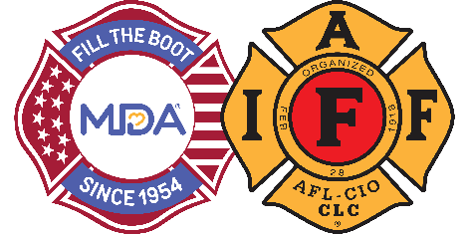
FOR IMMEDIATE RELEASE

Contact:
Contact Name
Contact Email
Contact Phone

$Amount Raised by City Fire Fighters During 2024 Fill the Boot Campaign to Support Muscular Dystrophy Association Celebrating 70 Years of Partnership
CITY (ALL CAPS), State, Month Day, 2024— During the 2024 Muscular Dystrophy Association (MDA) Fill the Boot campaign, the dedicated members of the Professional Fire Fighters Association Local ## took to the streets/store fronts and continued a 70-year tradition of raising funds to support MDA’s mission to accelerate research, advance care, and advocate for the support of families living with muscular dystrophy, ALS, and related neuromuscular diseases.

Insert your local FTB event information here, including locations, special activities you had, E.G. kick off events, etc.
“The fire fighters of Professional Fire Fighters Association Local ## have once again gone above and beyond for MDA’s families during this year’s Fill the Boot campaign,” said MDA Fire Fighter Partnership Rep. Title, Name. “We are so grateful for their dedication and for the generosity of those in the City community who have helped to raise critical funds for research and care, as we mark this historic milestone in our partnership with MDA.”

In addition to Fill the Boot drives, fire fighter contributions from year-round local events, including if applicable, insert additional local events FFs participate in, E.G. softball tournaments, galas, golf tournaments, etc. help support MDA families.

"Thanks to fire fighters filling the boot for decades, today we have more than 20 treatments for neuromuscular diseases approved by the FDA in just the past 12 years with many more in the pipeline. Together with the support of the International Association of Fire Fighters helping to accelerate research and advance care, we are empowering the families we serve to live longer, more independent lives. We are extremely grateful to IAFF for maintaining their strong commitment to the Fill the Boot program," says Donald S. Wood, Ph.D., President and CEO of MDA.
Funds raised through City Fill the Boot events go towards groundbreaking research, life-enhancing educational programs, a resource center, and support for multi-disciplinary medical teams at the MDA Care Center at Hospital Name(s) in Location(s). They also help send more than Number local kids to a transformative experience at MDA Summer Camp - all at no cost to families.
For more information about Fill the Boot or to donate online, please visit www.mda.org/ftb.

About the MDA and IAFF Partnership
The partnership between the IAFF and MDA began in 1954 when the organization committed by proclamation to support MDA until a cure is found, and the organization's unwavering commitment to MDA has remained strong to this day. As MDA’s largest national and top fundraising partner, they have raised more than $700 million for MDA to date. MDA is grateful for the hundreds of thousands of IAFF members across America who have participated in Fill the Boot campaigns over the last 70 years and joined in its mission to empower people living with neuromuscular diseases to live longer, more independent lives.

About the IAFF
The International Association of Fire Fighters represents more than 340,000 professional fire fighters and paramedics who protect more than 85% of the nation's population. More than 3,500 affiliates and their members protect communities in every state in the United States and in Canada. To learn more visit IAFF.org and follow the IAFF at Facebook, Twitter, and Instagram.

About Muscular Dystrophy Association
Muscular Dystrophy Association (MDA) is the #1 voluntary health organization in the United States for people living with muscular dystrophy, ALS, and related neuromuscular diseases. For over 70 years, MDA has led the way in accelerating research, advancing care, and advocating for the support of our families. MDA’s mission is to empower the people we serve to live longer, more independent lives. To learn more visit mda.org and follow MDA on Instagram, Facebook, Twitter, TikTok, and LinkedIn.
###

