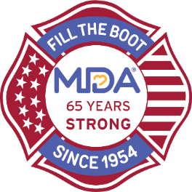
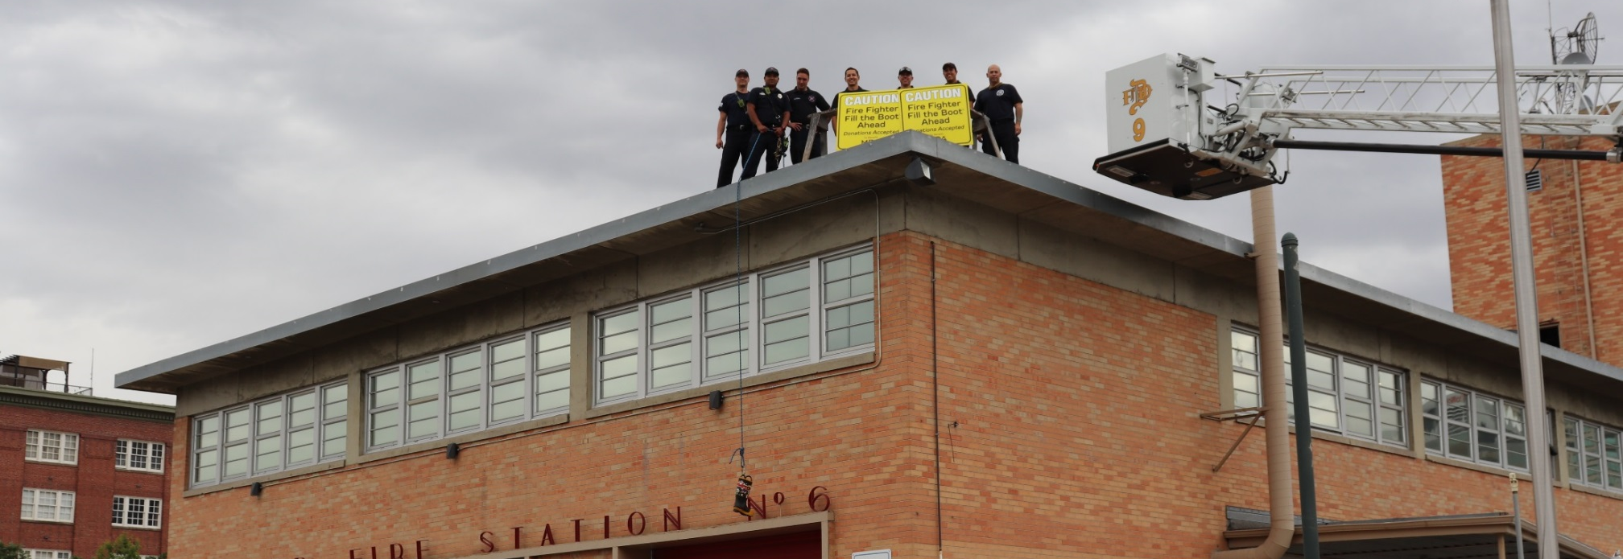
Local/Fire Department Name
Rooftop Rescue Sponsorship Opportunities

Showcase your corporate leadership with a connection to community heroes and leverage the 66-year partnership between MDA and fire fighters and to bring positive cause marketing benefits to your brand.

3rd Alarm Sponsor - $1,500 (smaller market) - $10,000 (larger market)
- recognition as presenting sponsor on press release and opportunity to speak at media kickoff
- MDA fire fighter and family stories for use by company for external and/or internal social & digital communications
- MDA staff or fire fighter participation in one virtual company meeting or event
- opportunity to hang company banner at event
- company logo placement on event website
- recognition on local/department and MDA social media channels
- opportunity for company to share involvement on social media

2nd Alarm Sponsor - $1,000 (smaller market) - $5,000 (larger market)
- recognition as event sponsor on press release
- opportunity to hang company banner at event
- company logo placement on event website
- recognition on local/department social media channels
- opportunity for company to share involvement on social media

1st Alarm Sponsor - $500 (smaller market) - $2,500 (larger market)
- recognition as event sponsor on press release
- company logo placement on event website
- recognition on local/department social media channels
- opportunity for company to share involvement on social media
For Additional Information Contact
Name
xxx.xxx.xxxx
email

