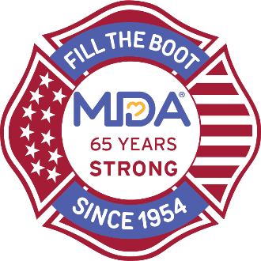
Event Name

Sponsorship Commitment Form

Thank you for your interest in partnering with Local/Fire Department Name to support MDA! Your support is greatly appreciated and will directly impact the lives of kids, adults and their families living with muscular dystrophy, ALS and related life-threatening diseases that take away muscle strength and mobility.

Select Sponsorship Level
❑ 3rd Alarm - $1,500 (smaller market) - $10,000 (larger market)
❑ 2nd Alarm - $1,500 (smaller market) - $10,000 (larger market)
❑ 1st Alarm - $1,500 (smaller market) - $10,000 (larger market)

Purchase a Sponsorship

I understand that my sponsorship will be confirmed upon receipt of this form and payment to MDA.
____________________________________________________________________________________________
Company Name
____________________________________________________________________________________________
Contact Name
____________________________________________________________________________________________Phone Email
____________________________________________________________________________________________
Address
____________________________________________________________________________________________City, State Zip

Payment Information

❑ Enclosed is my check for the total sponsorship amount. (All checks must be made payable to: MDA)
❑ We are unable to attend, but would like to make the enclosed tax-deductible contribution to MDA: $___________
❑ Please bill my (please check one):  Discover n  MasterCard n  Visa n  AMEX
____________________________________________________________________________________________Card# Exp. Date
____________________________________________________________________________________________
Name (as it appears on card) Billing ZIP Code
____________________________________________________________________________________________
Signature

Please return completed form and payments to contact name no later than Month Day, 20XX
Local/Fire Department Address | P: xxx.xxx.xxxx | email

