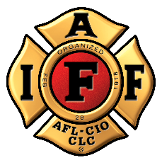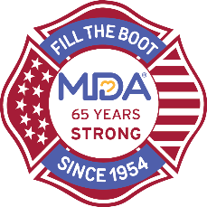
FOR IMMEDIATE RELEASE Contact: Contact Name
DATE Contact Email
Contact Phone

Help Rescue IAFF Fire Fighters as
COVID Threatens Fill the Boot for Muscular Dystrophy Association
In response to apprehensions about in-person fundraising, IAFF and MDA create touchless Fill the Boot to continue funding research for treatments and cures for muscular dystrophy, ALS and neuromuscular diseases.

[CITY (ALL CAPS)], [State], [Month] [Day], 2020 – As the COVID pandemic affects communities across the United States, it has also impacted in-person fundraising for the Muscular Dystrophy Association (MDA). For 66 years, [Professional Fire Fighters Association Local ##] has collected critical funds in the community – one dollar at a time – as part of the Fill the Boot program. But this year, due to social distancing, that’s not possible. In lieu of conducting their traditional fundraiser, [Professional Fire Fighters Association Local ##] are asking for your help to rescue them from the [location] rooftop on [date]. In order to focus on a more social-distancing approved form of collections amid the pandemic, local fire fighters will camp out on the [location] rooftop for [x hours/days] (rain or shine) to raise their goal of [$xx,xxx]. Donations help meet the urgent need for MDA’s Frontline COVID-19 Emergency Fund to continue services for more than 250,000 people living with neuromuscular diseases across the country.

We encourage the community to make donations online or deliver donations in person: https://filltheboot.donordrive.com/URL
You can also text ‘BOOT’ to 24325

[Professional Fire Fighters Association Local ##] displays an unwavering support for MDA year after year, raising critical funds and awareness to help our families get the care they need," says [MDA Rep Title], [Name]. "We are so thankful for their continued commitment to cure neuromuscular disease and for the flexibility to go virtual through this pandemic to protect everyone on the frontlines in our community.”

Donate at https://filltheboot.donordrive.com/URL or text ‘BOOT’ to 24325

Follow @MDAorg on Facebook, Instagram, Twitter

Follow the IAFF at Facebook.com/IAFFonline, twitter.com/@IAFFNewsDesk, Instagram.com/iaff1918

