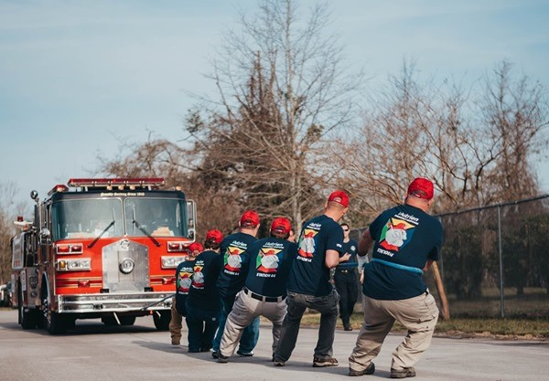

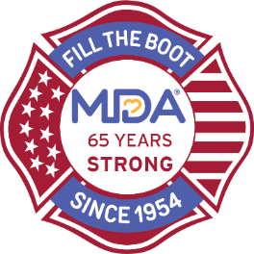

Local/Fire Department Name
Fire Engine Pull

Month Day, 20XX • Time

Location
Location Address

Join Local/Fire Department Name for a fun day of raising money for MDA

Register a team or donate at:
https://filltheboot.donordrive.com/event/enginepull

For more information, or to get involved, please contact:
Name, XXX-XXX-XXXX, email

