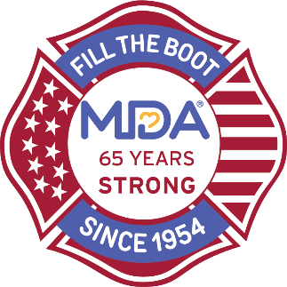
Fire Fighter Fundraising Events
Sample Donation Solicitation Templates

Template #1: Existing Relationship or Connection

Subject: Join local/fire department Fire Fighters in Supporting MDA

Dear contact name,

The fire fighters in local/fire department are proud supporters of the Muscular Dystrophy Association (MDA) with the relationship dating back over 65 years. We stand behind MDA and raise vital funds and awareness to help free kids and adults from the harm of muscle-debilitating diseases so they can live longer and grow stronger.

Because of the challenges of the pandemic this year, we are shifting how we fundraise for MDA, and we would like to invite company name to join us as a corporate sponsor of event name. This is a great opportunity to showcase your corporate leadership with a connection to community heroes to bring positive cause marketing benefits to your brand.

As an essential charity, MDA needs our support now more than ever and we’d appreciate any support you can offer. We would like to request that company name support our event by donating items/donating event space/donating an auction item/making a monetary donation. Event sponsorship opportunities are also available if you’d like to discuss this in greater detail.

We sincerely appreciate your time and consideration.

Thank you,
email signature

Template #2: Referred by Someone to this Contact

Subject: Name of Referrer Suggested We Reach Out to You

Dear contact name or company name,

Name of referrer suggested that I reach out to you to share what fire fighters in city/town are doing to support the local community. The fire fighters in local/fire department are proud supporters of the Muscular Dystrophy Association (MDA) with the relationship dating back over 65 years. We stand behind MDA and raise vital funds and awareness to help free kids and adults from the harm of muscle-debilitating diseases so they can live longer and grow stronger.

Because of the challenges of the pandemic this year, we are shifting how we fundraise for MDA, and we would like to invite company name to join us as a corporate sponsor of event name. This is a great opportunity to showcase your corporate leadership with a connection to community heroes to bring positive cause marketing benefits to your brand.

As an essential charity, MDA needs our support now more than ever and we’d appreciate any support you can offer. We would like to request that company name support our event by donating items/donating event space/donating an auction item/making a monetary donation. Event sponsorship opportunities are also available if you’d like to discuss this in greater detail.

We sincerely appreciate your time and consideration.

Thank you,
email signature

Template #3: Cold Outreach – No Contacts in Organization

Subject: Join local/fire department Fire Fighters in Supporting MDA

Dear company name,

The fire fighters in local/fire department are proud supporters of the Muscular Dystrophy Association (MDA) with the relationship dating back over 65 years. We stand behind MDA and raise vital funds and awareness to help free kids and adults from the harm of muscle-debilitating diseases so they can live longer and grow stronger. We also know that company name is known for being involved in our community, and we are pleased that our organizations share this commitment to doing the right thing.

Because of the challenges of the pandemic this year, we are shifting how we fundraise for MDA, and we would like to invite company name to join us as a corporate sponsor of event name. This is a great opportunity to showcase your corporate leadership with a connection to community heroes to bring positive cause marketing benefits to your brand.

As an essential charity, MDA needs our support now more than ever and we’d appreciate any support you can offer. We would like to request that company name support our event by donating items/donating event space/donating an auction item/making a monetary donation. Event sponsorship opportunities are also available if you’d like to discuss this in greater detail.

We sincerely appreciate your time and consideration.

Thank you,
email signature

