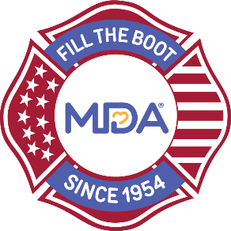

2021 Fill the Boot Safety Plan

Date:
Time:
Location/s:
Contacts:
- Local/Fire Department Coordinator
- MDA Staff Rep

Purpose of Safety Plan:
- Educate personnel on best practices in order to remain safe while participating in Fill the Boot
- Ensure all personnel are consistent in following safety guidelines
- Decrease risk of injury while participating in Fill the Boot

Preparation:
- All intersections must be formally identified prior to the start of the campaign
- Each intersection must meet the following criteria:
  - Good traffic control with traffic light
  - Good visibility
  - Ability to access vehicular traffic from a safe place (i.e. median, sidewalk, etc.)
- No collecting in any intersections after dark or in inclement weather where visibility may be limited
- Make sure to have plenty of water available
- Consult with City Traffic Control to determine the best flow, busiest time and least amount of accidents
- Intersections should be well-marked with cones, apparatus, and signs provided by the MDA (truck banners, caution signs, and smaller posters) to alert drivers of upcoming collection points
  - Apparatus should be highly visible. If allowable, keep emergency lights on.
  - DOT Variable Message Boards are suggested where available

COVID-Specific Considerations:
- Ask fire fighters not to participate if they are sick/not feeling well
- To limit the direct contact between firefighters and donors, do not hand stickers out after donations are made
- Communicate with Chief and City Council – ask for their input and guidance on your municipality’s safety restrictions
- Make sure all fire fighters wear proper personal protective equipment including masks
- Make sure all participants read the MDA COVID-19 Acknowledgement Form before collecting on behalf of MDA

All personnel operating within or near roadways must:
- Wear proper personal protective equipment including department-issued reflective safety vest, proper steel-toed footwear, helmet, and masks as required by local jurisdictions
  - MDA can provide safety vests as requested
- Maintain situational awareness of their surroundings and the people walking through collection sites
- Initiate all collections from roadside or median and never stop traffic or inhibit the flow of traffic, and only approach stopped vehicles
  - Fire fighters should move to the sidewalk or median during a green light
- Always maintain a professional attitude
- Hydrate prior to and continue to hydrate while collecting donations
- Apply sunscreen and wear hat or helmet to prevent over exposure to the sun
  - Attempt to stay in shaded areas

MDA Insurance:
- MDA’s Insurance Policy covers all active and retired fire fighters, cadets, fire fighters in training, and EMTs working or volunteering for Fire Departments, while volunteering on behalf of MDA. Only those covered by the policy can collect at intersections.

