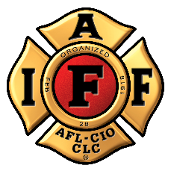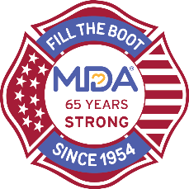
FOR IMMEDIATE RELEASE Contact: Contact Name
DATE Contact Email
Contact Phone

IAFF Fire Fighters Launch Virtual Fundraiser for Muscular Dystrophy Association as COVID Threatens Fill the Boot
In response to apprehensions about in-person fundraising, IAFF and MDA create touchless Fill the Boot to continue funding research for treatments and cures for muscular dystrophy, ALS and neuromuscular diseases.

[CITY (ALL CAPS)], [State], [Month] [Day], 2020 – As the COVID pandemic affects communities across the United States, it has also impacted in-person fundraising for the Muscular Dystrophy Association (MDA). For 66 years, the International Association of Fire Fighters (IAFF) has collected critical funds in the community – one dollar at a time – as part of the Fill the Boot program. But this year, due to social distancing, that’s not possible.

This summer, the [City] Fill the Boot will be conducted virtually at: https://filltheboot.donordrive.com/URL or by texting ‘BOOT’ to 24325
Donations collected by [Professional Fire Fighters Association Local ##] help meet the urgent need for MDA’s Frontline COVID-19 Emergency Fund to continue services for people living in our community with neuromuscular diseases across the country.

“For six decades, IAFF members have been at intersections across America with their fire boots to collect donations for MDA,” says IAFF General President Harold Schaitberger. “But the COVID pandemic and social distancing make that an impossibility. Virtual Fill the Boot will let our members continue to collect to help MDA meet their vital mission of finding treatment and cures for muscular dystrophy, ALS and other neuromuscular diseases.”

"IAFF members display an unwavering support for MDA year after year, raising critical funds and awareness to help our families get the care they need," says MDA CEO and President Lynn O'Connor Vos. "We are so thankful to IAFF and the [Professional Fire Fighters Association Local ##] for continuing their commitment to cure neuromuscular disease and for the flexibility to go virtual through this pandemic to protect everyone on the frontlines in our communities.”

Donate at https://filltheboot.donordrive.com/URL or text ‘BOOT’ to 24325

Follow @MDAorg on Facebook, Instagram, Twitter

Follow the IAFF at Facebook.com/IAFFonline, twitter.com/@IAFFNewsDesk, Instagram.com/iaff1918
###

